**EVEREST ENGINEERING COLLEGE**

  **SANEPA, LALITPUR**

(AFFILIATED TO POKHARA UNIVERSITY)

AN

LAB REPORT

ON

**Object Oriented Programming In C++**

***[Friend Function & Class]***

**Lab Sheet: 4**



**SUBMITTED BY SUBMITTED TO**

Name:-**SAKCHYAM ACHARYA** Er.Pradip Paudel

Roll No:-40 Everest Engineering College

Department of Computer Engineering

Faculty:-BE CMP

Year/Semester: - 2nd SEM

Batch: 2021

Verified By:-

Student's Signature

**Index Page:-**

Topics Page No

* Title, Objective....................................................................................3
* Theory……………………………………………………………………………….3
* Friend Function
* Friend Class
* Questions with Source Code & Output…………………………………………...3-14
* Discussion & Conclusion ...................................................................................14

**Title:- Friend Function & Class.**

**Objective:-**

* To be familiar with friend function & class.

**Theory:-**

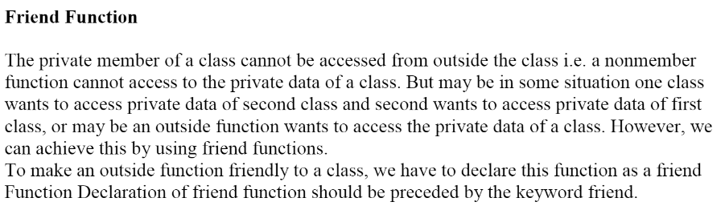

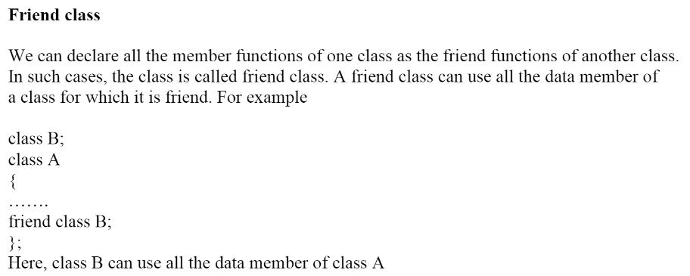

**Lab Problems:**

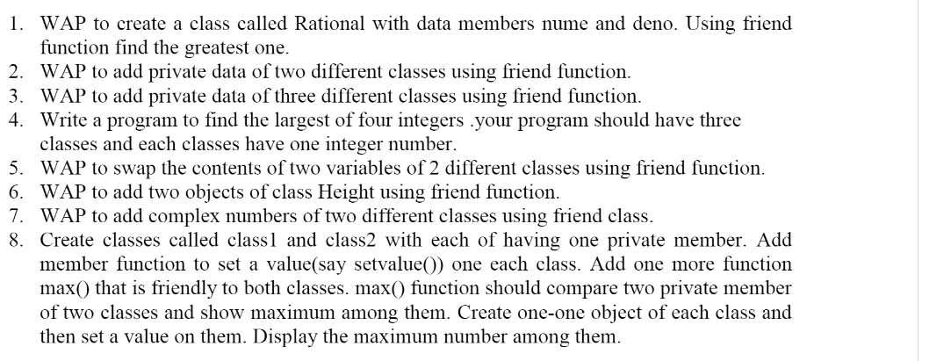

**///Prob1)**

**//Source Code:**

#include<iostream>

using namespace std;

class Rational{

private:

int numo,deno;

public:

void setData(int n1,int n2){

numo=n1;

deno=n2;

}

void max(void){

if (numo>deno) cout<<numo<<" is greater than "<<deno<<".";

else cout<<deno<<" is greater than "<<numo<<".";

}

};

int main(void){

Rational R1;

R1.setData(5,6);

R1.max();

return 0;

}

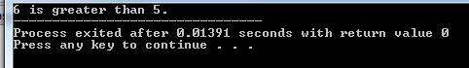

**///Prob2)**

**//Source Code:**

#include<iostream>

using namespace std;

class sum2;

class sum1

{

private:

int sak1;

public:

void inputdata(int no){

sak1=no;

}

friend void add(sum1 a,sum2 b);

};

class sum2

{

private:

int sak2;

public:

void inputdata(int no){

sak2=no;

}

private:

friend void add(sum1 a,sum2 b);

};

void add(sum1 a, sum2 b){

int temp;

temp= a.sak1 + b.sak2;

cout<<"Sum="<<temp<<endl;

}

int main(){

sum1 x;

sum2 y;

x.inputdata(10);

y.inputdata(20);

add(x,y);

return 0;

}

**///Prob3)**

**//Source Code:**

#include<iostream>

using namespace std;

class sum3;

class sum2;//forward declare

class sum1

{

private:

int sak1;

public:

void inputdata(int no){

sak1=no;

}

friend void add(sum1 a,sum2 b,sum3 c);

};

class sum2

{

private:

int sak2;

public:

void inputdata(int no){

sak2=no;

}

private:

friend void add(sum1 a,sum2 b,sum3 c);

};

class sum3

{

private:

int sak3;

public:

void inputdata(int no){

sak3=no;

}

friend void add(sum1 a,sum2 b,sum3 c);

};

void add(sum1 a, sum2 b, sum3 c){

int temp;

temp= a.sak1 + b.sak2 + c.sak3;

cout<<"Sum="<<temp<<endl;

}

int main(){

sum1 x;

sum2 y;

sum3 z;

x.inputdata(10);

y.inputdata(20);

z.inputdata(30);

add(x,y,z);

return 0;

}



**///Prob4)**

**//Source Code:**

#include<iostream>

using namespace std;

class c3;

class c2;

class c1

{

private:

int no1;

public:

void inputdata(int no){

no1=no;

}

friend void max(c1,c2,c3);

};

class c2

{

private:

int no2;

public:

void inputdata(int no){

no2=no;

}

friend void max(c1,c2,c3);

};

class c3

{

private:

int no3;

public:

void inputdata(int no){

no3=no;

}

friend void max(c1,c2,c3);

};

void max(c1 a,c2 b,c3 c){

int d;

cout<<"Enter the fourth variable:";

cin>>d;

if(a.no1>b.no2 && a.no1>c.no3 && a.no1>d ){

cout<<"Maximum Number="<<a.no1<<endl;

}

else if(b.no2>a.no1 && b.no2>c.no3 && b.no2>d){

cout<<"Maximum Number="<<b.no2<<endl;

}

else if(c.no3>a.no1 && c.no3>b.no2 && c.no3>d){

cout<<"Maximum Number="<<c.no3<<endl;

}

else{

cout<<"Maximum Number="<<d<<endl;

}

}

int main(){

c1 x;

c2 y;

c3 z;

x.inputdata(20);

y.inputdata(30);

z.inputdata(40);

max(x,y,z);

return 0;

}

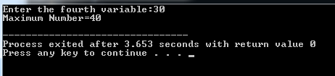

**///Prob5)**

**//Source Code:**

//WAP to swap the content of two variable of 2 different classes using friend function.

#include<iostream>

using namespace std;

class sample2;

class sample1

{

private:

int x;

public:

void inputdata(int n1){

x=n1;

}

void displaydata(){

cout<<"Value of x="<<x<<endl;

}

friend void swapvar(sample1 &,sample2 &);

};

class sample2

{

private:

int y;

public:

void inputdata(int n2){

y=n2;

}

void displaydata(){

cout<<"Value of y="<<y<<endl;

}

friend void swapvar(sample1 &,sample2 &);

};

void swapvar(sample1 &x1,sample2 &y1){

int ne;

ne=x1.x;

x1.x=y1.y;

y1.y=ne;

};

int main(){

sample1 x;

sample2 y;

x.inputdata(5);

y.inputdata(10);

cout<<"\nBefore swapping: \n";

x.displaydata();

y.displaydata();

swapvar(x,y);

cout<<"\nAfter swapping:\n";

x.displaydata();

y.displaydata();

return 0;

}

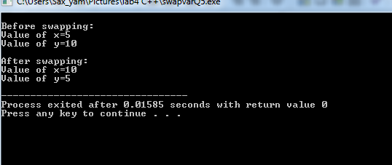

**///Prob6)**

**//Source Code:**

#include<iostream>

using namespace std;

class height{

private:

int feet,inch;

public:

void setData(void){

cout<<endl<<"Enter Feet?:";

cin>>feet;

cout<<"Enter Inch?:";

cin>>inch;

}

friend void sumheight(height,height);

};

void sumheight(height h1,height h2){

int inch,feet;

inch=h1.inch + h2.inch;

feet=h1.feet + h2.feet + (inch/12);

inch %=12;

cout<<endl<<"Sum of height="<<feet<<" ft"<<" : "<<inch<<" inch";

}

int main(void){

height h1,h2;

cout<<endl<<"For 1st height:";

h1.setData();

cout<<endl<<"For 2nd height:";

h2.setData();

sumheight(h1,h2);

return 0;

}

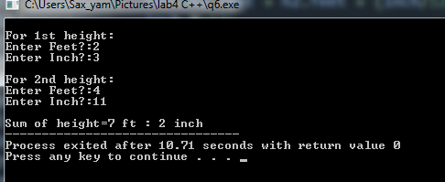

**///Prob7)**

**//Source Code:**

#include<iostream>

using namespace std;

class Complex1{

private:

int r,i;

public:

void getData(void){

cout<<"Real part?:";

cin>>r;

cout<<"Imaginary part?:";

cin>>i;

}

/*void dispdata(void){

cout<<"The sum of the entered two complex numbers is:"<<r<<"+"<<i<<"i";

}*/

friend class Complex2;

};

class Complex2{

private:

int r,i;

public:

void getData(void){

cout<<"Real part?:";

cin>>r;

cout<<"Imaginary part?:";

cin>>i;

}

void sumDat(Complex1 C1){

cout<<endl<<"The sum of two complex numbers is (a+ib)="<<(C1.r+r)<<"+"<<(C1.i+i)<<"i"<<".";

}

/*void dispData(void){

cout<<endl<<"The sum of the entered two complex numbers is:"<<r<<"+"<<i<<"i";

}*/

};

int main(void){

Complex1 C1;

Complex2 C2;

cout<<endl<<"For 1st Complex No:\n";

C1.getData();

cout<<endl<<"For 2nd Complex No:\n";

C2.getData();

C2.sumDat(C1);

return 0;

}

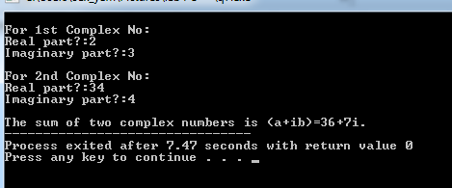

**///Prob8)**

**//Source Code:**

#include<iostream>

using namespace std;

class class2;

class class1

{

private:

int m1;

public:

void setvalue(int no){

m1=no;

}

friend void comp(class1 a,class2 b);

};

class class2

{

private:

int m2;

public:

void setvalue(int no){

m2=no;

}

friend void comp(class1 a,class2 b);

};

void comp(class1 a, class2 b){

if(a.m1>b.m2){

cout<<"Maximum Number="<<a.m1<<endl;

}

else{

cout<<"Maximum Number="<<b.m2<<endl;

}

}

int main(){

class1 x;

class2 y;

x.setvalue(20);

y.setvalue(30);

comp(x,y);

return 0;

}

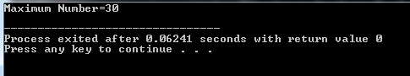

**Discussion & Conclusion:-**

The program is focused on various tasks on “**Friend Function & Class**”. From this program I understood how to add object of different class using friend function & I also learnt about forward declaration.

**Thank You**<SAKWheels>